**A Maker’s World: Wearables with Circuit Playground**

**Instructor**: Natalia Baklitskaya (natalia.baklitskaya@gmail.com)

For this workshop, the PC in front of you already has Arduino IDE installed. We have also pre-installed the IDE Adafruit boards support and Adafruit NeoPixel (programmable LEDs) library. If you would like to set these up on your personal or work computer outside of this workshop, please follow instructions outlines in Packet 3.

In this portion of the workshop, we will be working with an **Adafruit Circuit Playground**.

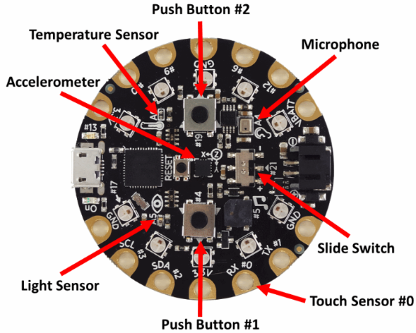

Circuit Playground is Adafruit's fully-featured wearable electronics platform. It's a round, sewable, Arduino-compatible microcontroller designed to empower amazing wearables projects. Circuit Playground comes with Adafruit's support, [tutorials and projects](http://learn.adafruit.com/category/flora). Check out dozens of Circuit Playground tutorials on the Adafruit Learning System, with more added all the time!

**Adafruit Circuit Playground** has **fewer pins than an Arduino Uno**, but it is **compact**, which makes it great for wearables. It is also loaded with sensors, such as temperature, accelerometer, light, microphone and touch, as well as switches and button. It also **has a JST connector for a LiPo battery**, and **on/off switch**, and **nice big pads for its pins**, which are great for sewing through with conductive thread. It can also survive gentle washes (but don’t stick this mictrocontroller in the dryer!).

**INSTRUCTIONS**

1. Pick up the Circuit Playground microcontroller.
2. Attach the NeoPixel to the microcontroller by connecting VBATT to **+** terminal of the NeoPixel, GND to the **–** terminal of the NeoPixel, and one of the numbered digital pins (try pin **10**) to the **input** to the NeoPixel, similar to the diagram below for a Gemma microcontroller.

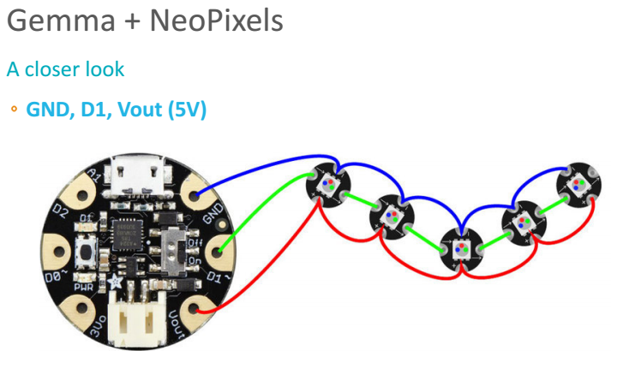

1. Locate the micro USB cable at the tables. Plug one end of it into Circuit Playground, and the other into the laptop at your desk.
2. Open Arduino IDE by double clicking on the teal Arduino icon on your desktop.
3. Open ***File > Examples > Adafruit NeoPixels > simple***

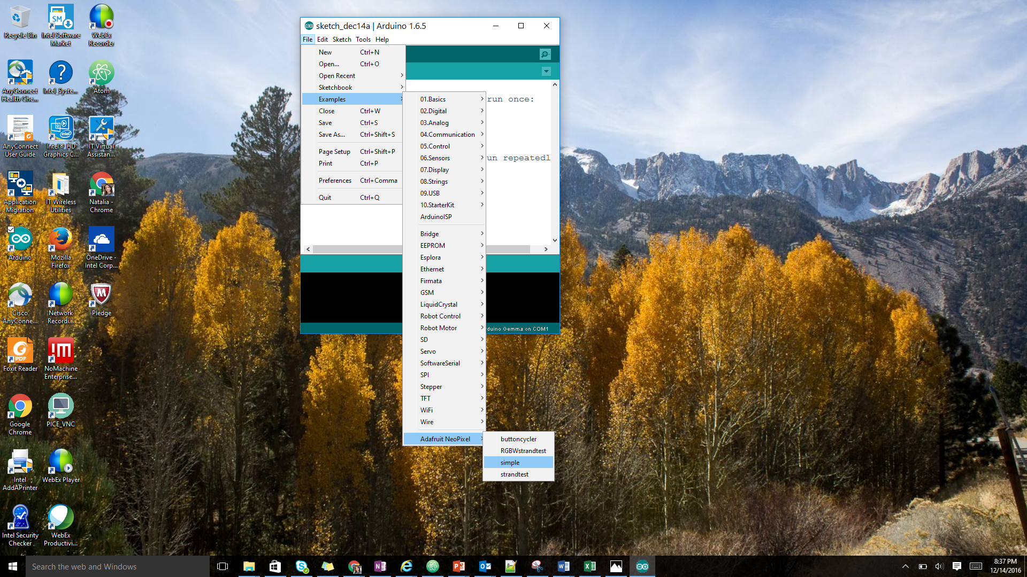

1. Modify the code to work with your microcontroller:
   1. Adjust the value of **PIN** on line 11 to correspond to the output pin on your Circuit Playground that is feeding the serial input to the NeoPixels.

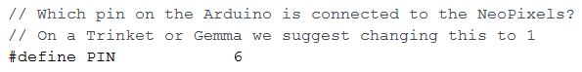

* 1. Adjust the value of **NUMPIXELS** on line 14 to correspond to the number of NeoPixels connected to the Circuit Playground.

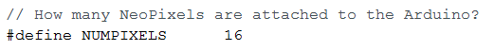

1. Change the Board settings under Tools to ‘Adafruit Circuit Playground’. 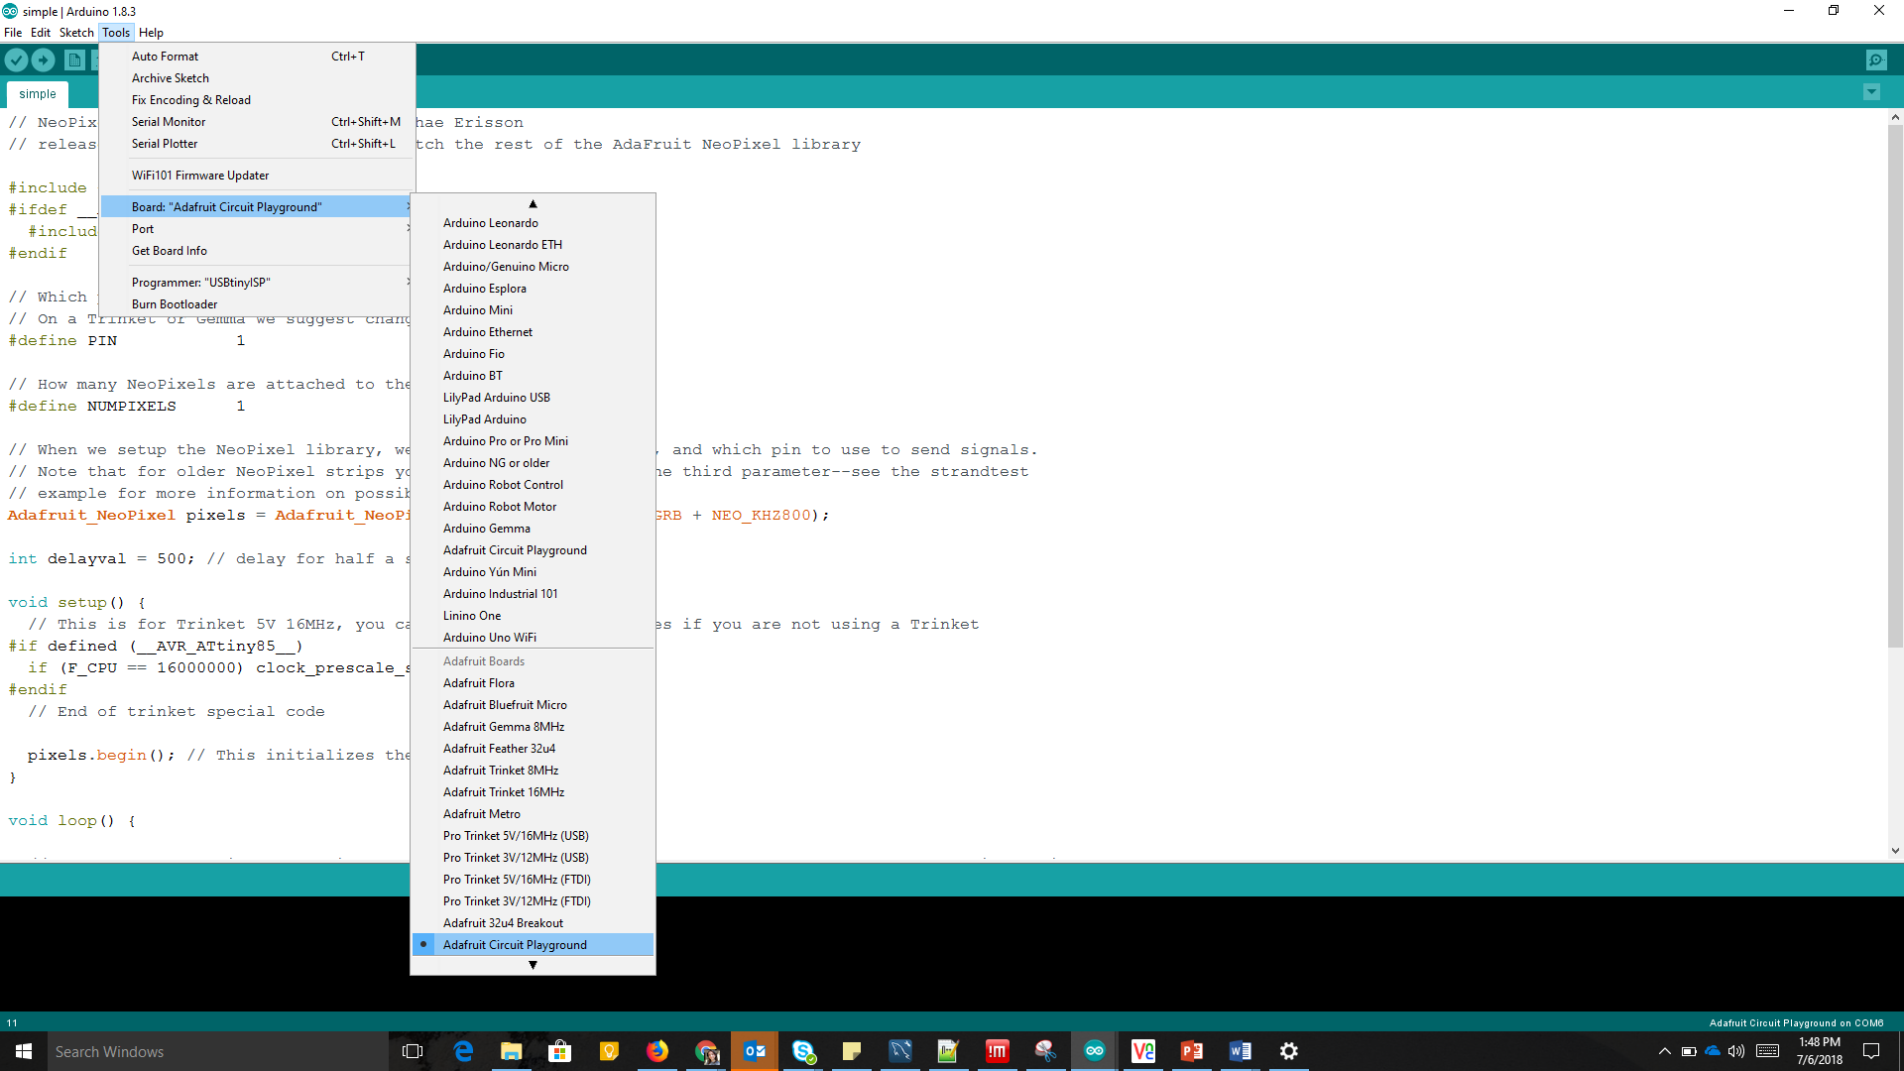
2. Change the Port settings under Tools to ‘COM## Circuit Playground.
3. Save your program by going to **File > Save** (or hit **Ctrl+S**).
4. Compile your code by clicking the check mark in the upper left corner in your window. Check for errors at the bottom of the window.

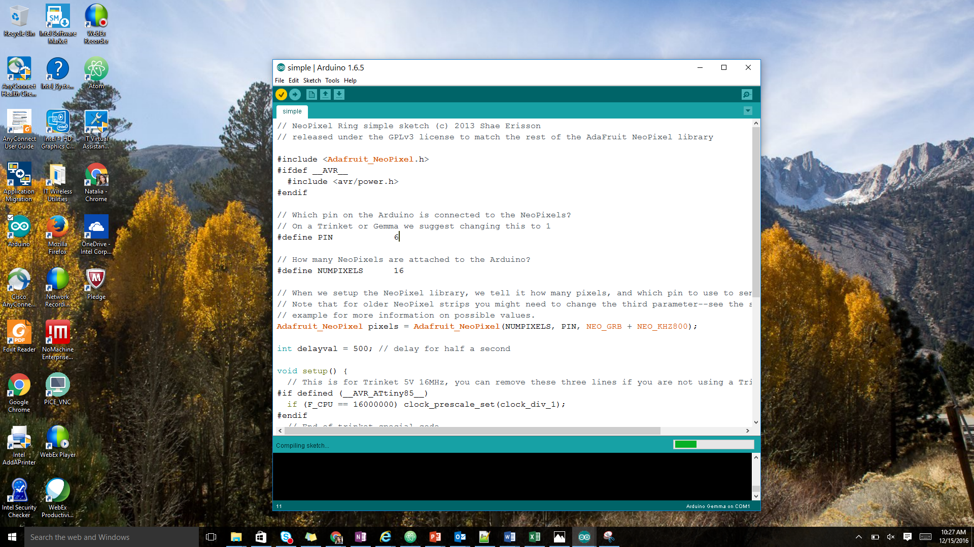

1. Turn on your Circuit Playground by flipping the switch on the board to ‘On’.
2. Upload the code to your Circuit Playground while the red light is flashing on the board.

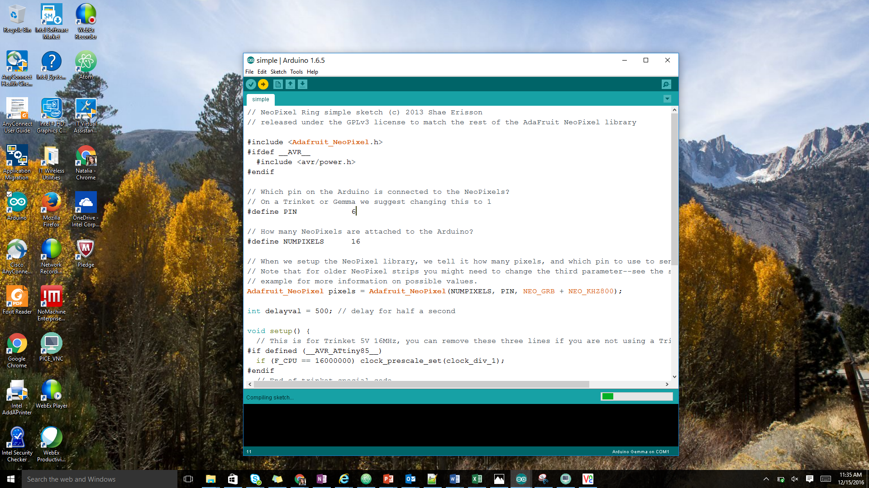

1. The NeoPixel connected to your Circuit Playground should be glowing **green**. Adjust your code to make the NeoPixel to first light up in **green** for 1 second, then **blue** for 1 second, then **red** for 1 second, all in a loop. Demonstrate your circuit to a TA once you are done.

**Hint:** you may want to consider replicating the lines below and adjusting them for different colors.

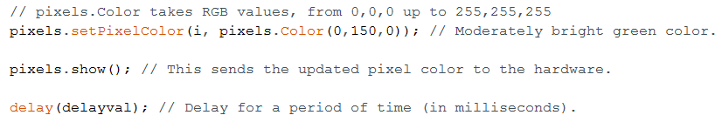

1. Now let’s switch your circuit to a more compact power source. Connect the battery to the Circuit Playground.
2. Unplug the USB cable from the Circuit Playground. Your circuit is now powered by a rechargeable battery!

**Strandtest: more colors = more fun!**

1. Connect your microcontroller to the PC using the USB cable.
2. Open ***File > Examples > Adafruit NeoPixels > strandtest***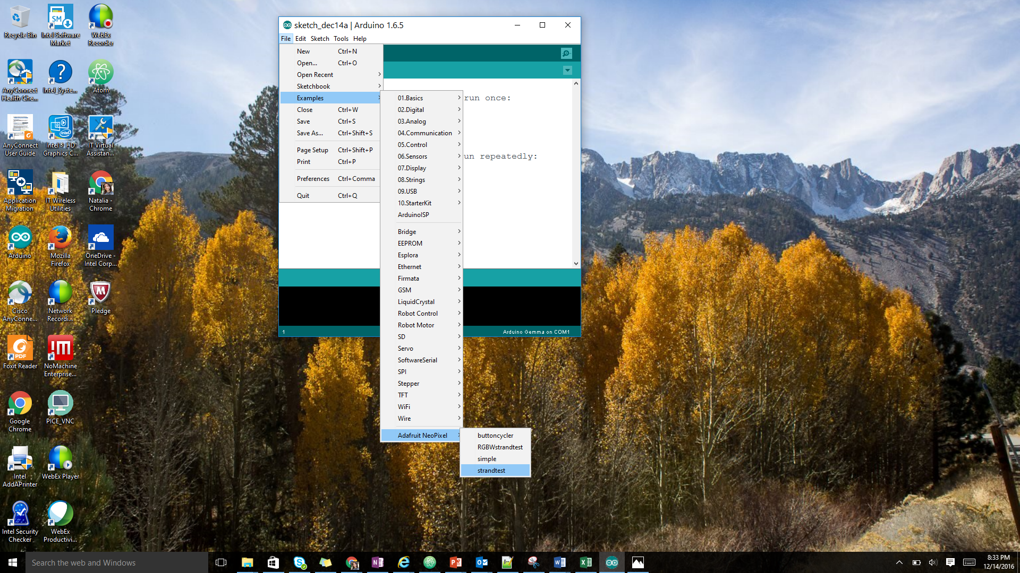
3. Adjust the value of **PIN** on line 6 to correspond to the output pin on your microcontroller that is feeding the serial input to the NeoPixels.
4. Adjust the number of NeoPixels on line 16 to correspond to the number of NeoPixels connected to your microcontroller.
5. Compile your code by clicking the check mark in the upper left corner in your window. Check for errors at the bottom of the window.



1. Turn on your microcontroller by flipping the switch on the board to ‘On’.
2. Upload the code to your microcontroller.



1. Observe the awesome patterns being displayed by your circuit. These get even cooler when you have more NeoPixels connected in sequence. Look through the code and look at the pre-programmed functions that are being used to create these patterns. You can modify these example functions and create your own patterns!